**INNOVATIVE PROJECT**

1. **ACCIDENT ALERT SYSTEM SOS**

**INTRODUCTION**

The aim of this project is to design an Accident Alert System using Arduino MPU6050, GPS and GSM module. The purpose of the system is to detect accidents and send alerts to emergency services and relatives/friends of the victim(s) through SMS messages. This project is designed to provide a cost-effective solution to the problem of road accidents.

**HARDWARE COMPONENTS**

1. Arduino UNO R3
2. LCD I2C
3. SIM800L GSM Module
4. NEO6M GPS Module
5. 2G Micro SIM
6. Piezoelectric Buzzer
7. Push button sensor
8. Resistors
9. Connecting wires
10. Breadboard
11. Buzzer
12. Power Supply (9V DC)

**SOFTWARE COMPONENTS**

1. Connecting
2. Arduino IDE
3. TinyGPS Library
4. Adafruit MPU6050 Library
5. GSM Library

**DESCRIPTION**

This Project is to Send SOS whenever the Vehicle is Crashed or Meets an accident. This project is made using Arduino Uno.

* Arduino Uno is an open-source microcontroller board based on the processor ATmega328P. There are 14 digital I/O pins, 6 analog inputs, a USB connection, a power jack, an ICSP header, and a reset button.

The Logic we considered to declare a vehicle is through the change in Acceleration and Angular acceleration/rotation of the vehicle. The sensor used for this is mpu6050.

* MPU-6050 is a Six-Axis (Gyro + Accelerometer) MEMS MotionTracking™ Devices.

Whenever there is a change more than the threshold value, the Arduino gets triggered and sends a command to make a message to the Given Mobile no. along with the location ( geographical position) of the vehicle where the incident happened. The Module used to facilitate this is SIM800L GSM module + 2g sim card And NEO-6M GPS

* SIM800L GSM/GPRS module is a miniature GSM modem, which can be integrated into a great number of IoT projects. You can use this module to accomplish almost anything a normal cell phone can; SMS text messages, make or receive phone calls, connecting to the internet through GPRS.
* The NEO-6M GPS module is a well-performing complete GPS receiver with a built-in 25 x 25 x 4mm ceramic antenna, which provides a strong satellite search capability.

**WORKING**:

The system works by continuously monitoring the vehicle’s movements using the MPU6050 sensor. When an accident occurs, the MPU6050 detects the sudden change in the vehicle’s acceleration and sends an interrupt to the Arduino. The GPS module is then used to get the vehicle’s current location and the information is sent to the GSM module using the Arduino. The GSM module then sends an alert SMS message to the emergency services and the victim’s relatives/friends. The alert SMS message contains the location of the accident and a request for immediate help.

The system also includes an LED and a buzzer that are used to indicate the status of the system. When the system is turned on, the green LED is turned on and the buzzer sounds a beep. If an accident is detected, the red LED is turned on and the buzzer sounds continuously until the system is turned off.

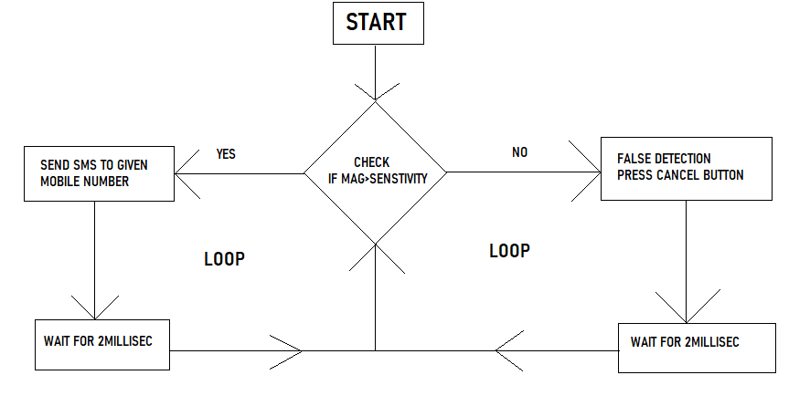

Figure A

Shows the working of the Alert system

**CIRCUIT DIAGRAM**

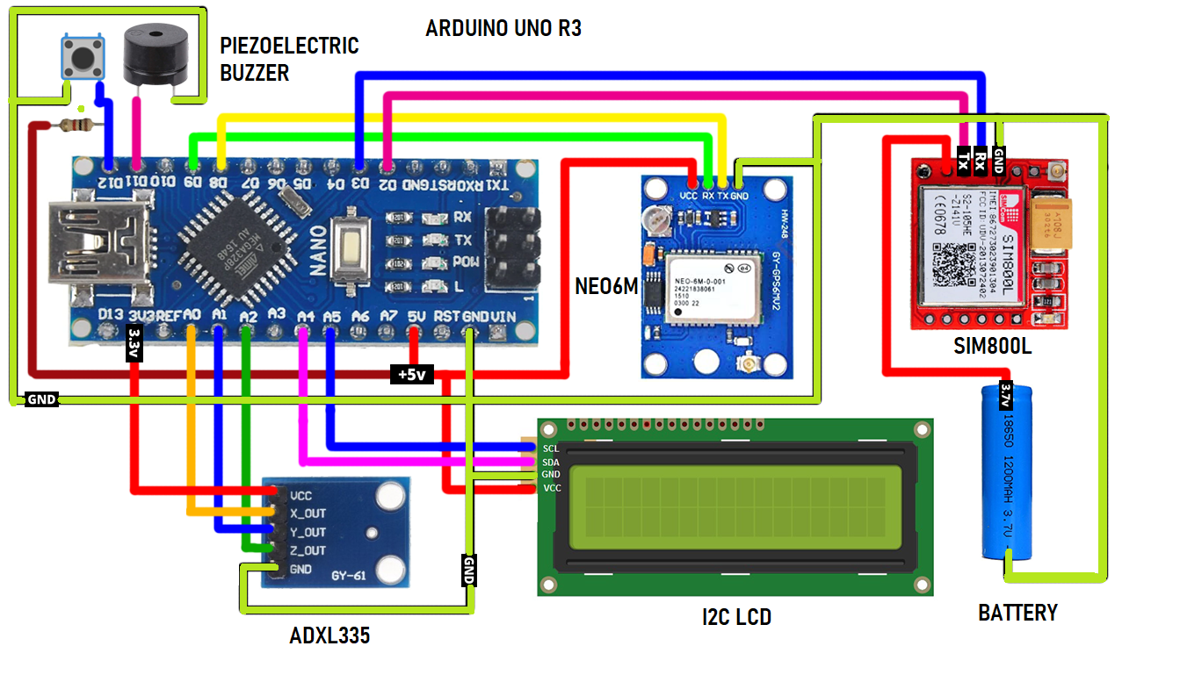

Figure B

This figure shows the overall circuit of the Accident Alert System with all the necessary components including modules

**CONCLUSION**

The Accident Alert System using Arduino MPU6050, GPS and GSM module is a low-cost solution to the problem of road accidents. The system is designed to detect accidents and send alerts to emergency services and relatives/friends of the victim(s) through SMS messages. The system is easy to install and can be used in all types of vehicles. The system can save lives and reduce the number of fatalities caused by road accidents.

1. **AUTO-CUTOFF SYSTEM**

**ABSTRACT**

In this project, an auto cutoff system has been designed using Arduino to detect the tilt of a bike and turn off the battery supply if it tilts more than a specific angle. The system uses an accelerometer sensor to detect the tilt angle and an Arduino microcontroller to process the data and control the battery supply. The main objective of the project is to enhance the safety of the bike riders by preventing accidents due to bike tilt.

**INTRODUCTION**

Accidents caused by bike tilt are one of the major causes of bike-related fatalities. In most cases, the rider is thrown off the bike due to the tilt, resulting in serious injuries or death. To prevent such accidents, an auto cutoff system can be used that detects the tilt of the bike and turns off the battery supply if it tilts more than a specific angle. The system can be easily integrated into the bike's existing electrical system, and it does not require any significant modifications to the bike.

**METHODOLOGY**

The system uses an accelerometer sensor to detect the tilt angle of the bike. The accelerometer sensor is connected to the Arduino microcontroller, which processes the data and controls the battery supply. The Arduino microcontroller is programmed to read the data from the accelerometer sensor continuously and compare it with a preset threshold value. If the tilt angle exceeds the threshold value, the microcontroller sends a signal to the battery supply control unit, which turns off the battery supply.

**COMPONENTS**

• Arduino Uno R3 microcontroller

• ADXL335 accelerometer sensor

• Relay module

• Jumper wires

• 9V battery

The ADXL335 accelerometer sensor is a three-axis sensor that measures the acceleration in three directions. It has a range of ±3g, which is sufficient for detecting the tilt of the bike. The sensor is connected to the Arduino microcontroller using jumper wires.

The relay module is used to control the battery supply. When the Arduino microcontroller sends a signal to the relay module, it switches off the battery supply.

**RESULT**

The system was tested using a bike, and it was found to be effective in detecting the tilt of the bike and turning off the battery supply if it tilts more than a specific angle. The threshold angle was set to 45 degrees, which is a safe angle for most bikes. The system was able to detect the tilt angle accurately, and it responded quickly to turn off the battery supply.

**CONCLUSION**

The auto cutoff system designed using Arduino is an effective solution to prevent accidents caused by bike tilt. The system is easy to implement, and it does not require any significant modifications to the bike. The system can be easily integrated into the bike's existing electrical system, and it provides an added layer of safety to the bike riders. The system can be further improved by adding additional sensors and integrating it with the bike's GPS system to provide real-time location-based services.